“A new direction to a promising future”  Merrimack county  Juvenile Services  LUnch N’ Learn | - June 8  - Noon-1pm  - •  - Bessie rowell Community Center  - BYOL- Bring your own lunch
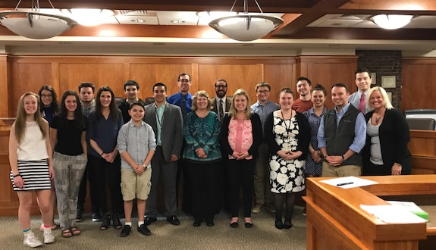  Merrimack County Juvenile Services  Join the Franklin Mayor’s Drug Task Force as we host Merrimack County Juvenile Services.  Learn about  - Juvenile Diversion, results and effectiveness  (A second chance for first time offenders)  - Substance misuse prevention programming  - Teen Court  - Volunteer Opportunities (teens and adults)  - Community Accountability Board  - Job Shadowing and Community Service Engagement | 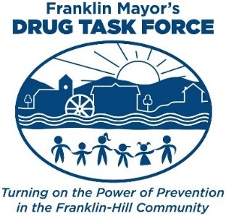  RSVP  Kayla Bertolino,  Coalition Coordinator  taskforceinfo@franklinnh.org  Cell 603-998-5337  Office 603-934-7446

